**Homework 3**

Problem 1.

Create a Web Page like the following.

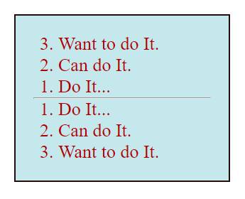

Create two files: “**reversed-list.html**”and“**reversed-list.css**”

### Constraints

* **<div>** with **id=wrapper** as a **container**
  + Background color: **#c5e8ec;**
  + Text color: **#b30000;**
  + Width container: **300px;**
  + Border: **1px solid #260d0d;**

Problem 2.

Create a Web Page like the following.

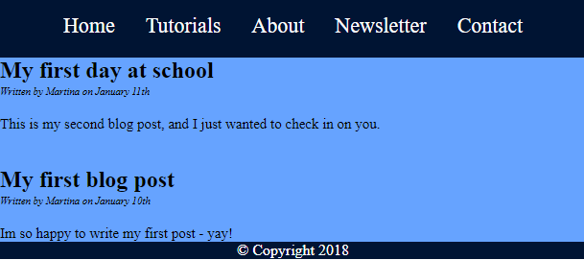

### Choose your own text and colors!

Create two files: "**simple-website.html**"and"**simple-website.css**".

Problem 3.

Create a Web Page like the following.

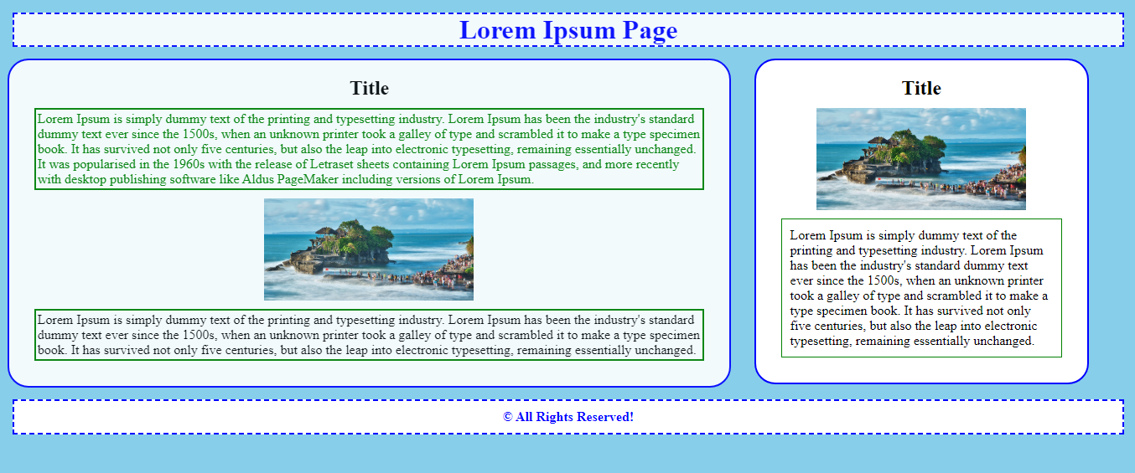

### Choose your own text, pictures and colors!

Create two files: "**index.html**" and "**style.css**".

Use **semantic HTML** to create the page!